February 2016
The Mechanical Engineering Department of the University of Tokyo uses a Renishaw inVia confocal Raman microscope to study graphene and other nano-materials in the development of energy related devices such as solar cells.
The University of Tokyo’s Department of Mechanical Engineering was established in 1879, providing education based on four disciplines; mechanics, materials, hydrodynamics and thermodynamics.
Within the Department, the Maruyama-Chiashi Laboratory focuses its research on the synthesis and analysis of carbon nanotubes (CNT), graphene and other nano-materials. They study applications related to the development of energy related devices, such as solar cells. The laboratory uses scanning Raman spectroscopy as an important tool for the investigation of the synthesized materials and their structure.
Lecturer Dr Shohei Chiashi says, “The Renishaw inVia is one of the most frequently used instruments in our university. Scanning Raman imaging spectroscopy is very useful for observing the structure of CNTs and graphene. It is one of the most important tools for our research. We find it possible to measure Raman images quickly and stably using inVia. Additionally, we find the software very useful for image analysis.”
Dr Chiashi, along with Professor Maruyama and colleagues, recently published two papers where the inVia was used as one of the principal characterisation tools. The first¹ reports the Raman characterisation of single layer hexagonal graphene flakes produced from ethanol via chemical vapour deposition. The second² uses systematic Raman mapping to evaluate single-walled carbon nanotubes of different chirality.
David Reece, Marketing Manager of the spectroscopy group at Renishaw, commented, “inVia is used throughout the world as an essential tool for researchers investigating the unique properties of CNT and graphene. I am glad to see our growing customer base publishing such excellent research utilising our equipment in this exciting area.”
Please visit www.renishaw.com/invia for further details of Renishaw’s inVia confocal Raman microscope.
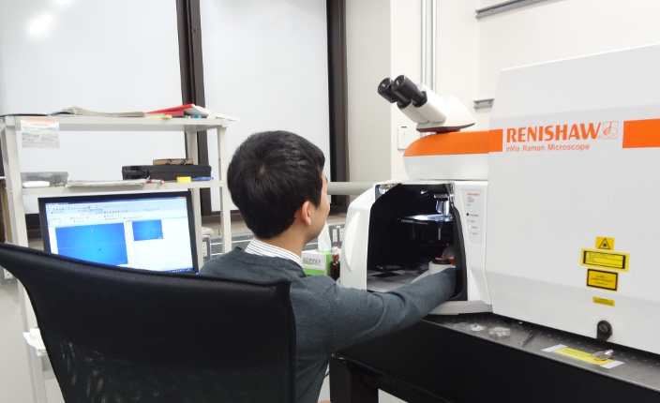
Image: Dr Taiki Inoue (Assistant Professor) of the Department of Mechanical Engineering, University of Tokyo, using their inVia confocal Raman microscope
References
^{1.} X. Chen, P. Zhao, R. Xiang, S. Kim, J. H. Cha, S. Chiashi, S. Maruyama, "Chemical Vapor Deposition Growth of 5 mm Hexagonal Single-Crystal Graphene from Ethanol," Carbon, 94, 810-815 (2015). DOI: 10.1016/j.carbon.2015.07.045.
^{2.} T. Inoue, D. Hasegawa, S. Chiashi, S. Maruyama, "Chirality Analysis of Horizontally Aligned Single-Walled Carbon Nanotubes: Decoupling Populations and Lengths," J. Mater. Chem. A, 3, 15119-15123 (2015). DOI: 10.1039/C5TA02679B.
Acknowledgement
Professor S Maruyama and Dr S Chiashi would like to acknowledge the cooperation of the Laser Alliance at the Institute of Engineering Innovation, School of Engineering, University of Tokyo, Japan.
-Ends-
About Renishaw
Renishaw is one of the world's leading engineering and scientific technology companies, with expertise in precision measurement and healthcare. The company supplies products and services used in applications as diverse as jet engine and wind turbine manufacture, through to dentistry and brain surgery. It is also a world leader in the field of additive manufacturing (also referred to as 3D printing), where it is the only UK business that designs and makes industrial machines which ‘print' parts from metal powder.
The Renishaw Group currently has more than 70 offices in 33 countries, with over 4,000 employees, of which 2,700 people are employed within the UK. The majority of the company's R&D and manufacturing is carried out in the UK and for the year ended June 2015 Renishaw achieved sales of £494.7 million of which 95% was due to exports. The company's largest markets are the USA, China, South Korea, Germany and Japan.
The Company's success has been recognised with numerous international awards, including eighteen Queen's Awards recognising achievements in technology, export and innovation. Renishaw received a Queen’s Award for Enterprise 2014, in the Innovations category, for the continuous development of the inVia confocal Raman microscope. For more information visit www.renishaw.com

For further information
Please contact:
David Reece
Renishaw plc
New Mills
Wotton-under-Edge
Gloucestershire GL12 8JR UK
Tel: +44 1453 523968 (direct)
Tel: +44 1453 524524 (switchboard)
Fax: +44 1453 523901
Email: david.reece@renishaw.com
www.renishaw.com/raman

