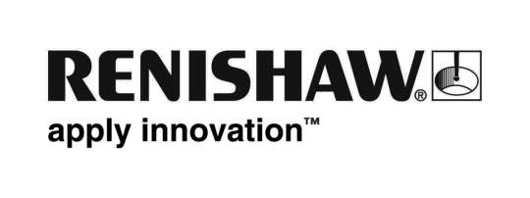
Enquiries: Chris Pockett, Group Marketing Services Manager (+44 1453 524133)

‘Consistently high performance’ earns Renishaw another Queen’s Award for Enterprise

On Wednesday 20th July, Renishaw plc was presented with a Queen’s Award for Enterprise 2011 by Dame Janet Trotter, Her Majesty’s Lord-Lieutenant of Gloucestershire. This is Renishaw’s fourteenth Queen’s Award since its formation in 1973, and was granted in the Innovations category for the company’s TRS2 laser-based non-contact broken tool detection system. The product is used for detecting broken or missing cutting tools on computer numerically controlled (CNC) machining centres.

The Lord-Lieutenant was welcomed to Renishaw’s headquarters at New Mills near Wotton-under-Edge, by Sir David McMurtry, the company’s Chairman and Chief Executive. Together with Rebecca Lane, who represented the many Renishaw employees connected with the TRS2 product, he accepted the Award in the form of a crystal bowl engraved with the Queen’s Award Emblem. The Citation was read by the Clerk to the Lieutenancy, Mrs Jane Burns, Director of Strategy at Gloucestershire County Council.

Speaking about Renishaw’s latest award, Dame Janet said, “Renishaw is a consistently high achiever with the highest number of Queen’s Awards in Gloucestershire. To be honoured with one award is a significant achievement, but consistently high performance day-by-day, week-by-week, year-by-year, in the way that you do constitutes true excellence.”

She added, “Consistent means reliable and constant to the same principles, and it is the result of team work, a company culture which strives for excellence, effective leadership, and recognising that second best is never an option. So congratulations to you all on being a jewel in the Gloucestershire crown.”

In response, Dr Tim Prestidge, Director and General Manager of the Machine Tool Products Division thanked Dame Janet for her kind words and said, “This award recognises the hard work of many staff in the wider Renishaw family who combined to create a commercially successful innovation, from design and development through to manufacture and sales.”

The Queen’s Awards for Enterprise are the UK’s most prestigious awards for business performance, which recognise and reward outstanding achievement by UK companies. Ends
About Renishaw
UK-based Renishaw is a world leading engineering technologies company, supplying products used for applications as diverse as jet engine and wind turbine manufacture, through to dentistry and brain surgery. It is Gloucestershire’s largest business employer, with over 1,600 staff based at its five sites in the county, plus a further 1000 people located in the 30 countries where it has wholly owned subsidiary operations.

Throughout its history Renishaw has made a significant commitment to research and development, with around 18% of annual sales invested in R&D and engineering. The majority of this R&D and manufacturing of the company’s products is carried out in Gloucestershire, where due to strong growth it currently has 150 vacancies.

The Company’s success has been recognised with numerous international awards, including fourteen Queen’s Awards recognising achievements in technology, export and innovation. Renishaw is listed on the London Stock Exchange (LSE:RSW) where it is a constituent of the FTSE 250, with a current valuation in excess of £1.2 billion.

Further information at www.renishaw.com

Enquiries:
Chris Pockett,
Group Marketing Services Manager
T: +44 (0)1453 524133
M: +44 (0)7887 833391
E: chris.pockett@renishaw.com

